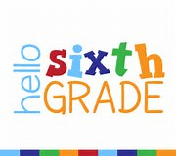
Mrs. Fox’s 6th Grade ELA Class Syllabus
Room: 11
Phone: 615-824-3456

Email: cathy.fox@sumnerschools.org
Website: https://cathyfox.educatorpages.com

Welcome to Language Arts class! I am so excited to get this year rolling!!! The purpose of this class is to further develop the reading, writing, speaking, listening, viewing, and critical thinking skills so necessary for your academic, professional, and personal success. During this school year, we will focus on literature study, vocabulary development, writing, grammar, and research/reference skills. We will explore a range of genres—fiction and nonfiction—from both a reading and writing standpoint.

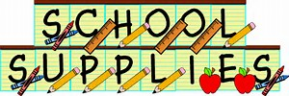
DAILY REQUIRED MATERIALS
- Several sharpened Pencils
- Hawkins Handbook/Agenda
- A spiral notebook, binder with notebook paper and class handouts, and composition book (Each should be labeled with students name and ELA)

OPTIONAL/HIGHLY RECOMMENDED MATERIALS
- Personal copy of class novel:
We will begin the year reading The Lightening Thief by Rick Riordan. Students who bring their own copy will be encouraged to annotate the text as we read making it much easier to refer to the text for the various text based activities that will go along with the unit. Of course, students who do not have a personal copy may borrow one of mine but will not be able to annotate directly within the text.

GRADING PROCEDURES
Your grade will be based on a combination of the following areas:

- Content Mastery (80%)
  - This includes any type of graded work or assessment—such as tests, quizzes, essays, presentations, book reports, projects, class work and homework— that demonstrates student mastery of skills and content.
- Participation/Preparedness/Effort) (20%)
  - This includes a classroom participation grade as well as skill-building and practice activities, bell work, end-of-class summary activities, journal entries, etc.

CLASSROOM POLICIES and BEHAVIOR EXPECTATIONS
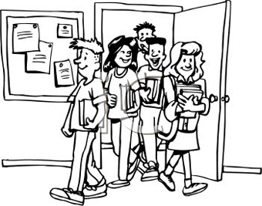
Responsibilities and Behavior

Your responsibilities in this class are:
- To attend class regularly;
- To be on time;
- To be prepared for class;
- To meet deadlines (all assignments due at the beginning of each class on the due date);

Your behavior expectations are:
- Listen when someone is talking (S.L.A.N.T.)
- Follow directions
- Treat others with respect and kindness
- Take care of the school, classroom, materials

All students are expected to be positive, contributing, respectful members in this class. Be polite and thoughtful of one another. Any behavior that prevents our class from functioning well or any display of disrespect will not be tolerated. The following outlines classroom/school rewards and consequences.
We use a point system to track student behaviors. At the beginning of each week, each student will automatically be awarded a total of 40 points. At the end of the week, any student who has kept between 32 to 40 points will be invited to bring their personal technology devices to class for Technology Friday.

Points will be deducted for the following infractions:

Attendance
Distracting Noises
Head Down/ Off task
Late/Missing Work
Missing Materials
Misuse of Materials
Neck Slapping
Off task/talking
Off topic comments
Out of Seat without permission
Outburst (Verbal)
Rude comment or gesture
School Policy: Items not allowed
School Policy: Dress code violation
School Policy: Tech violation
Substitute: Poor and/or disrespectful behavior for a substitute teacher
Talking back to authority
Tardy to class
Touching others or other's property without permission

Zero tolerance infraction (violent action or threat of violence). Student will be immediately sent to the office

Students may earn points back at the end of each week for excellent grades. One point per A average in each of the academic and related arts classes will be added back into a student's account.

Points will be awarded each Thursday afternoon and will be calculated the following Thursday afternoon. Points will start over each week. Students who have kept between 32-40 points will be invited to bring their personal technology devices to class on Friday (Technology Friday).

CLASSROOM CONTRACT

This page is considered an assignment, due:

This syllabus is a contract between you, the student, and me, the teacher. By signing below, you agree to what has been discussed on the previous pages. You are agreeing to be an active learner and participant during the exciting year ahead!

________________________________ __________________
Student Name (Printed) Period

________________________________ __________________
Student Signature Date

Parents/Guardians

I am looking forward to a productive and rewarding year working with your child! Please read the attached syllabus and sign below to acknowledge that you have read through the contents. If you have any questions please feel free to contact me at the email address provided in your syllabus.

________________________________ __________________
Parent/Guardian Signature Date

